Kyle Bush

CSCI 2467 HW_1

**Linux Commands**

sudo dpkg –configure -a

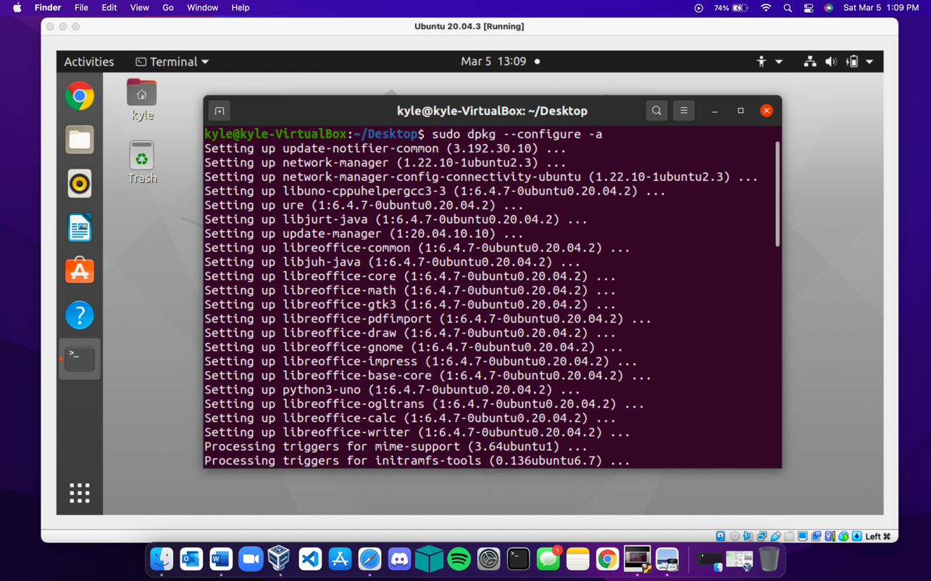

sudo apt-get install software-properties-common

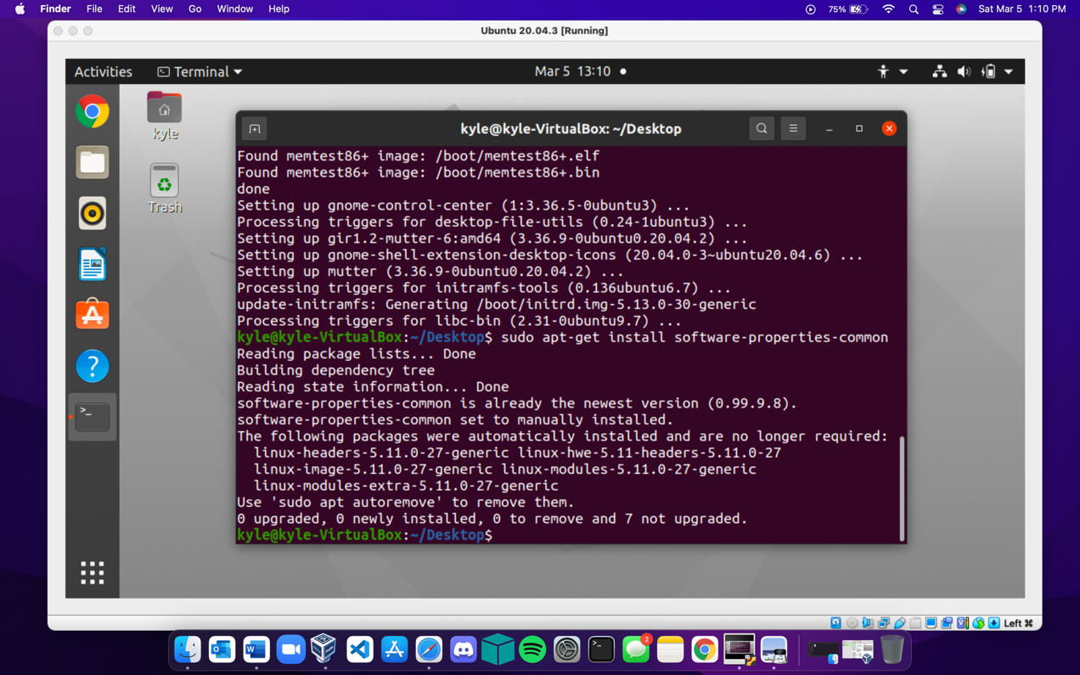

lsb_release -a

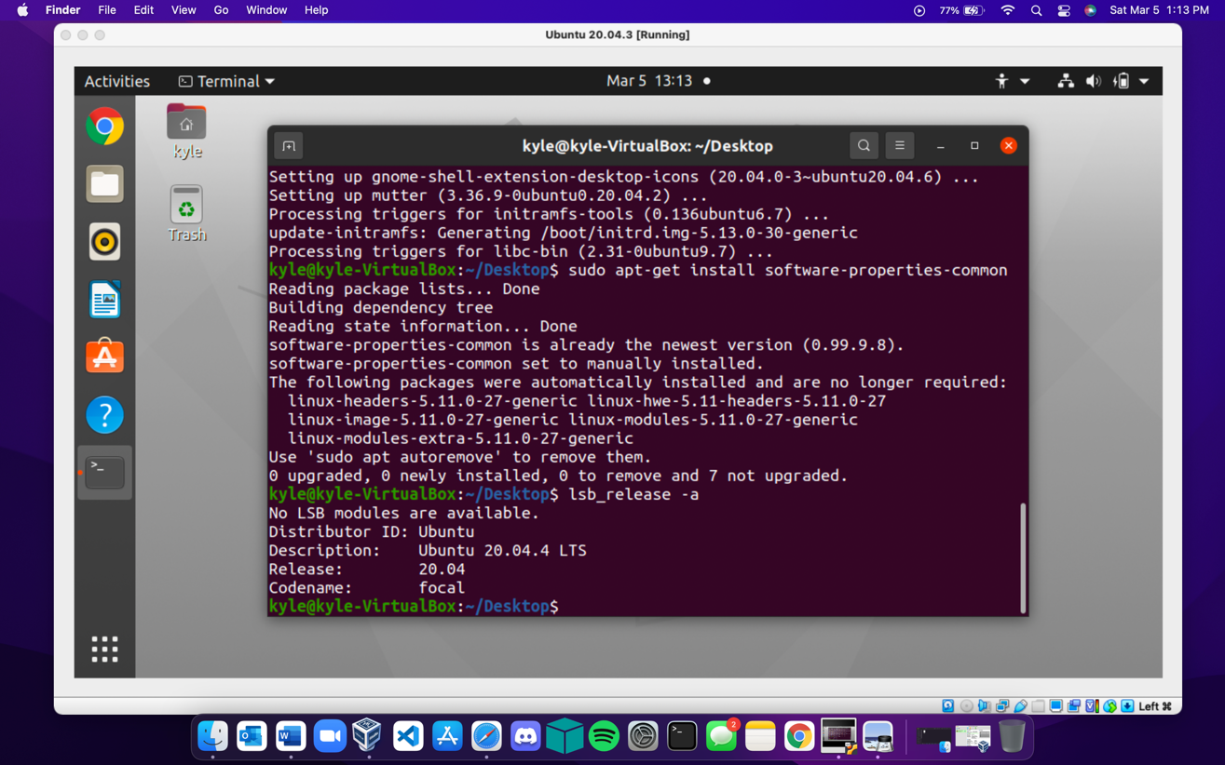

apt

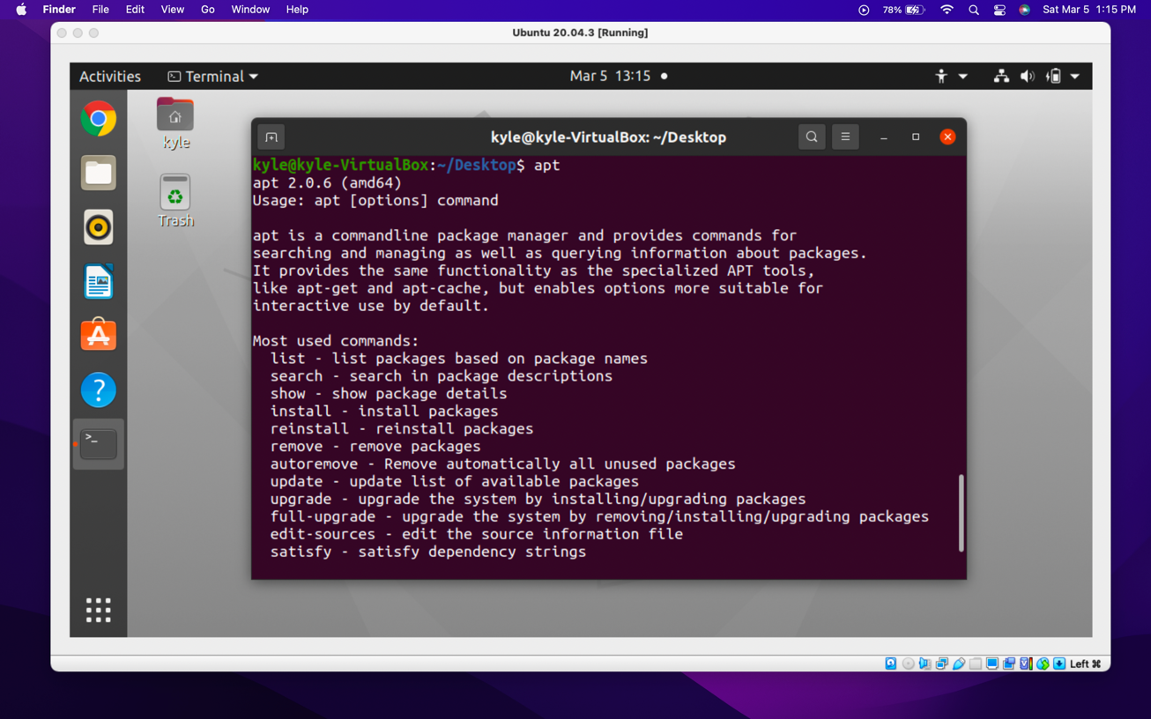

sudo snap install curl # version 7.81.0 (needed curl to install homebrew)

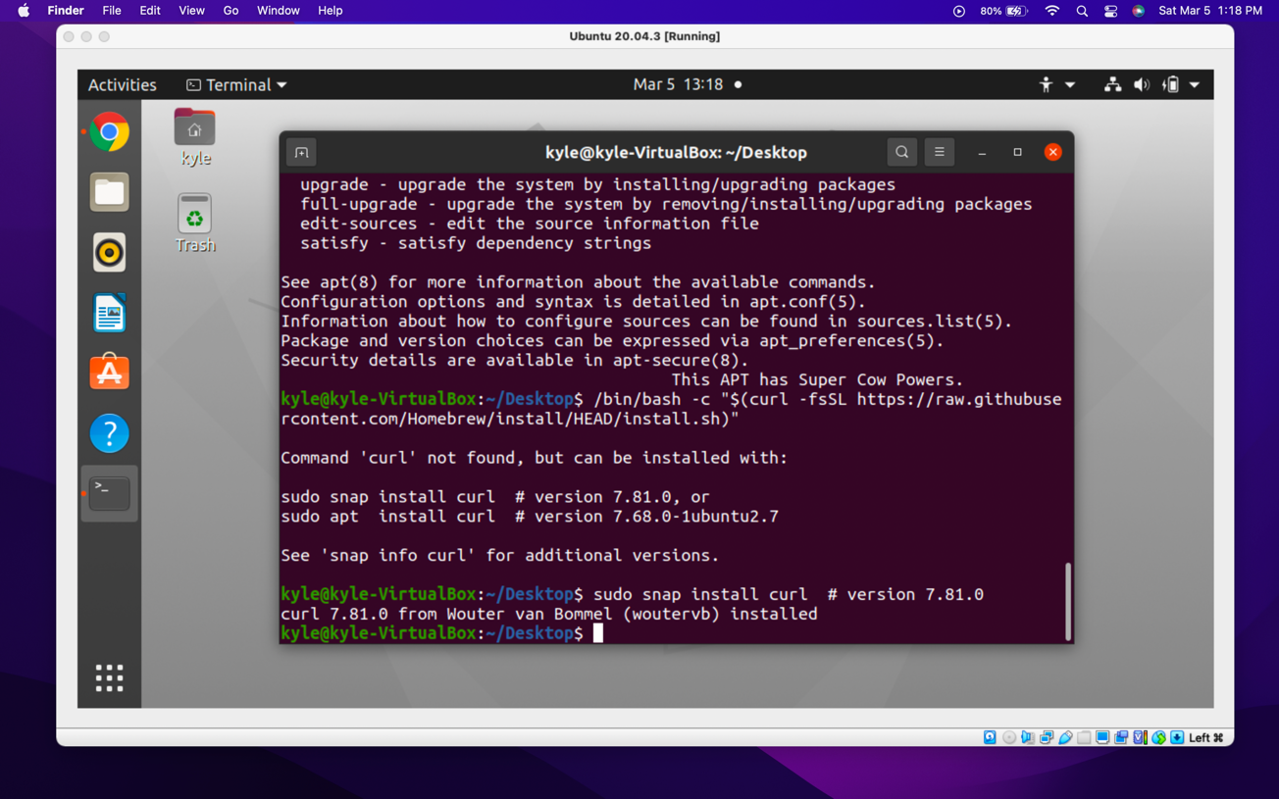

sudo apt install ruby # version 1:2.7+1 (needed ruby for homebrew install)

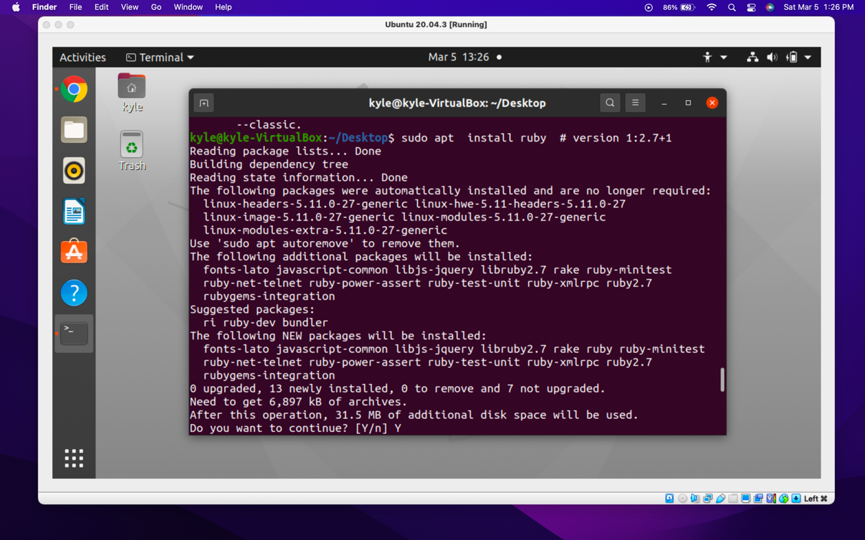

sudo apt install rbenv

For some reason, the previous ruby installation did not work for homebrew, so when researching why, I found it was recommended to use sudo to install rbenv.

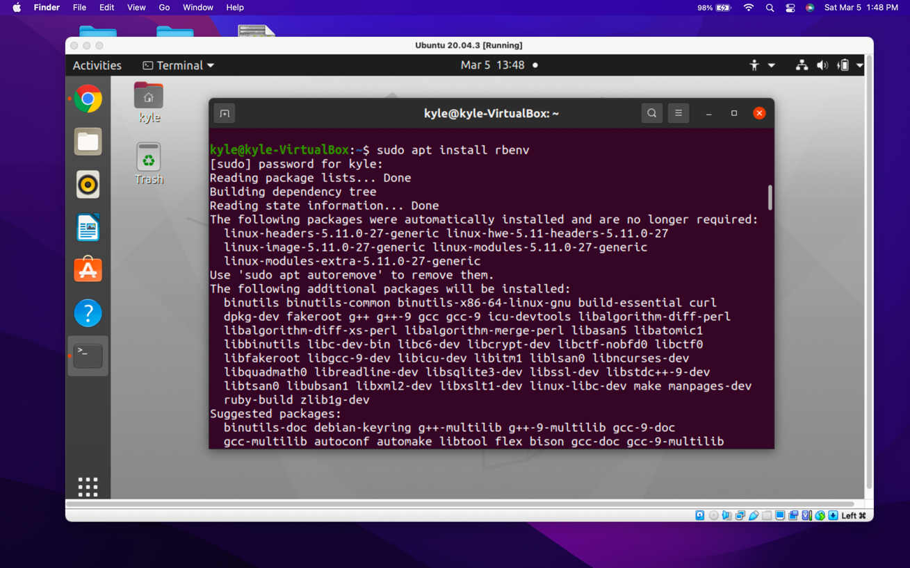

/bin/bash -c "$(curl -fsSL <https://raw.githubusercontent.com/Homebrew/install/HEAD/install.sh>)"

This was the homebrew installation. I decided to use homebrew since I am familiar with using it on MacOS.

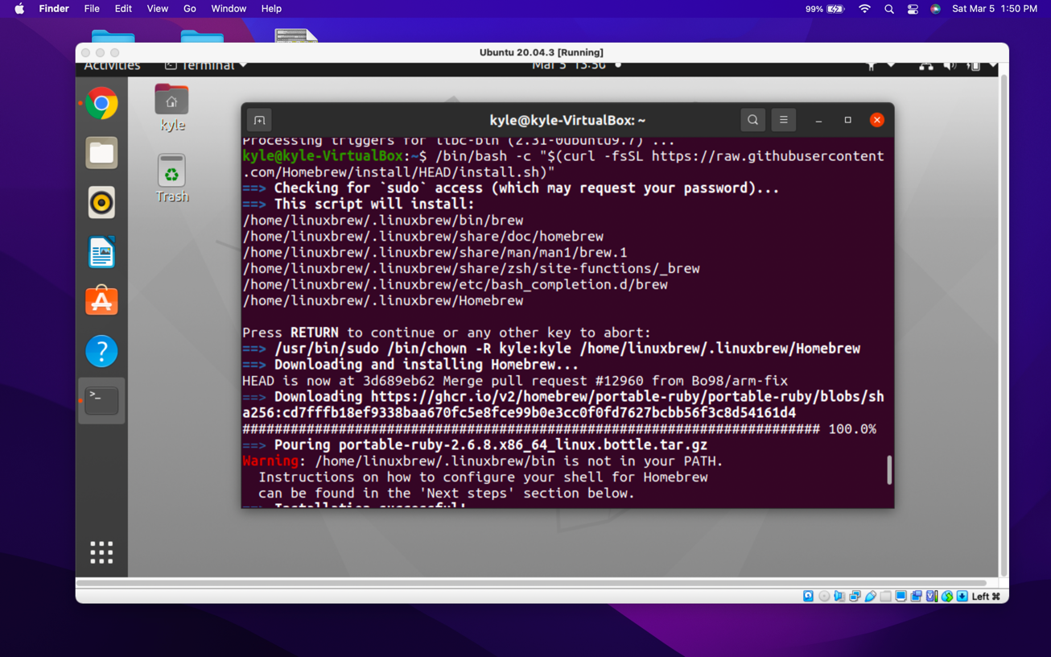

The next two lines were to add Homebrew to the file path so that I can use to to install necessary packages for neovim, the text editor I would like to learn to use on my linux machine during the semester.

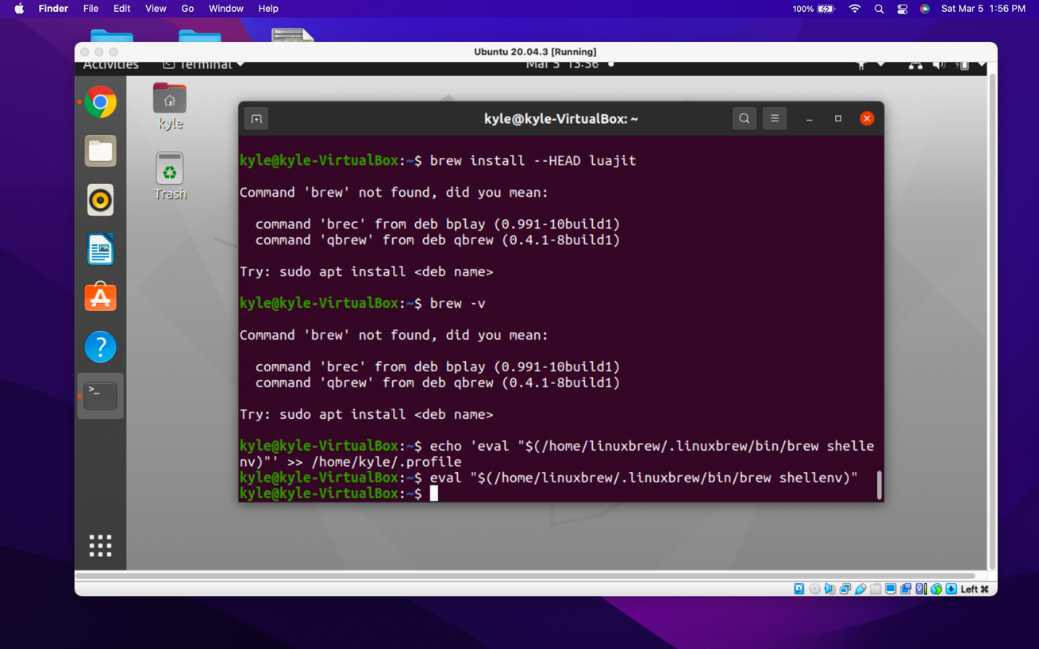

Installing lua for neovim

brew install --HEAD luajit

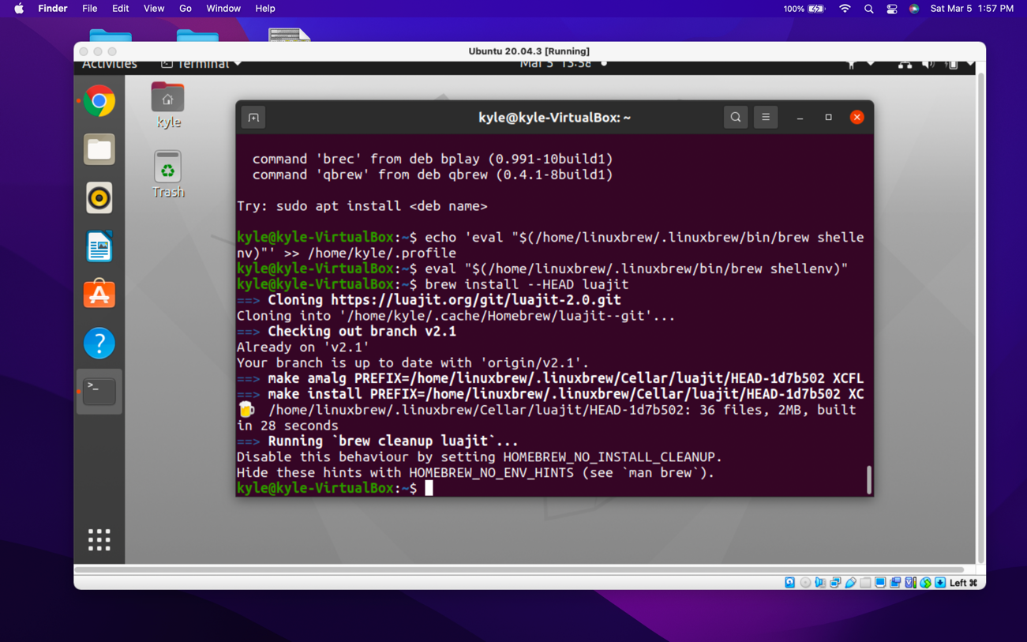

brew install --HEAD neovim

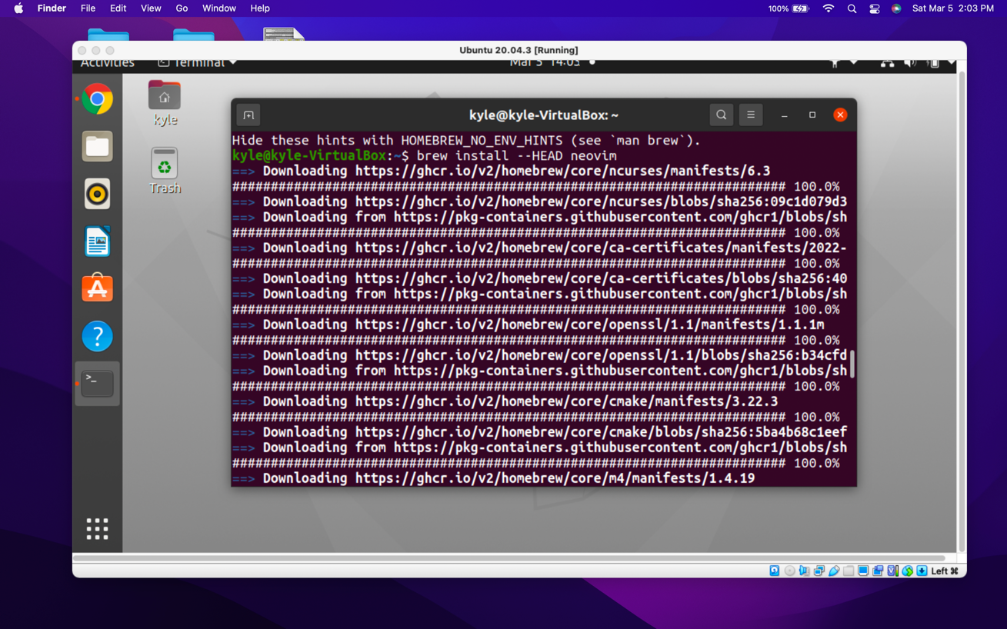

After neovim installation, typing “nvim” opens the text editor

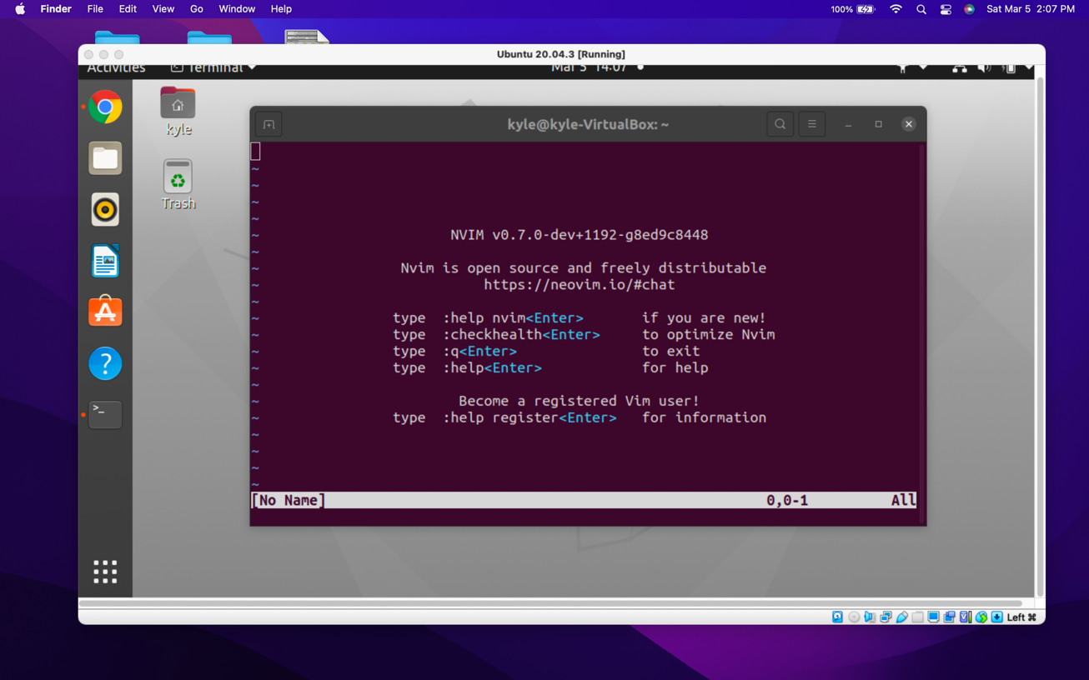

date

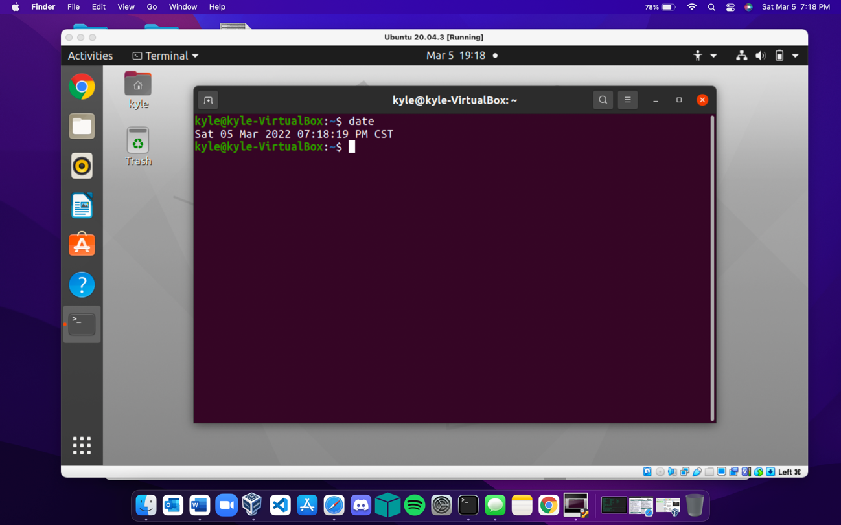

cal

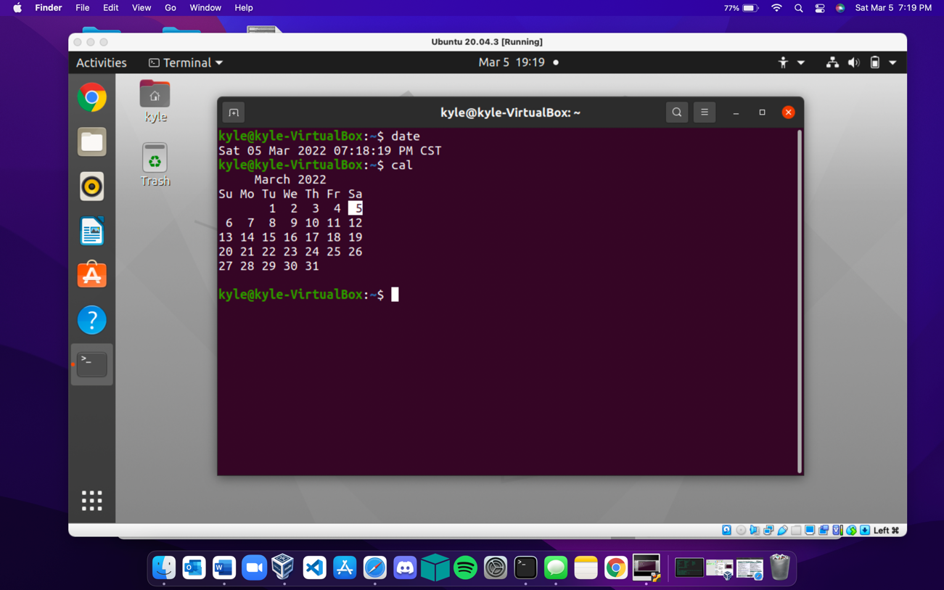

ls

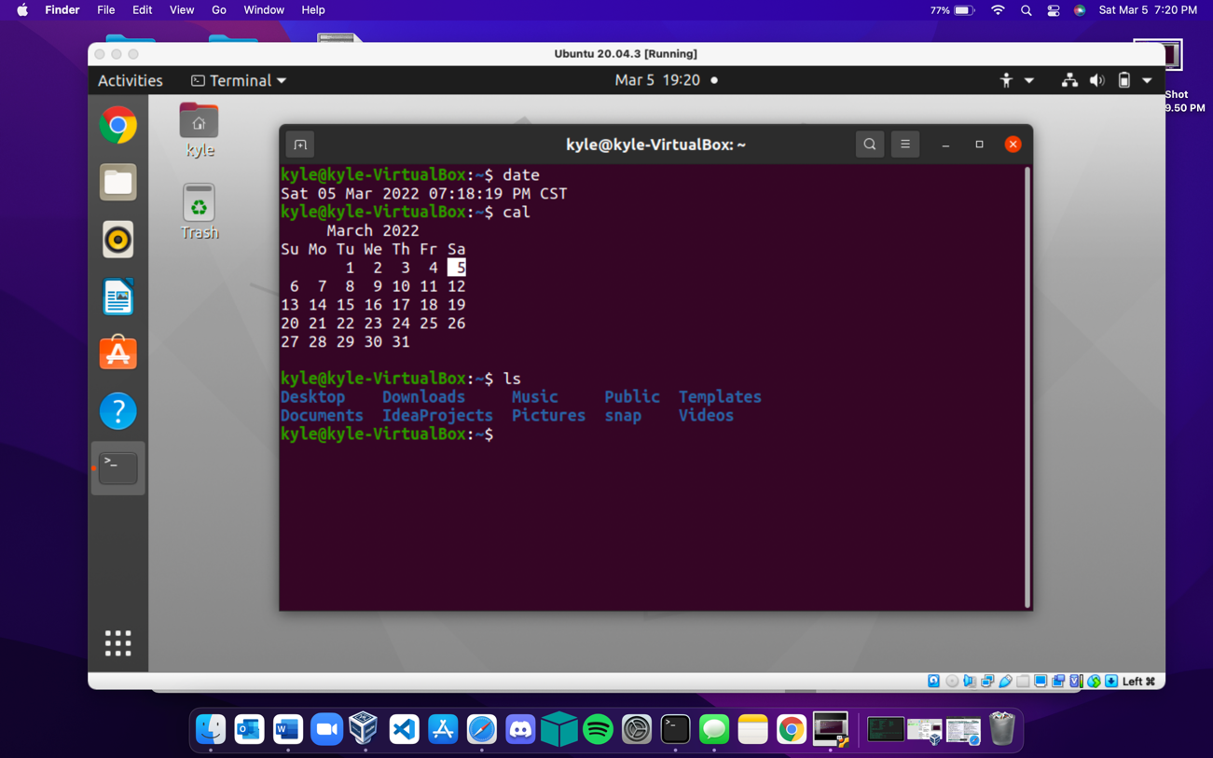

mkdir

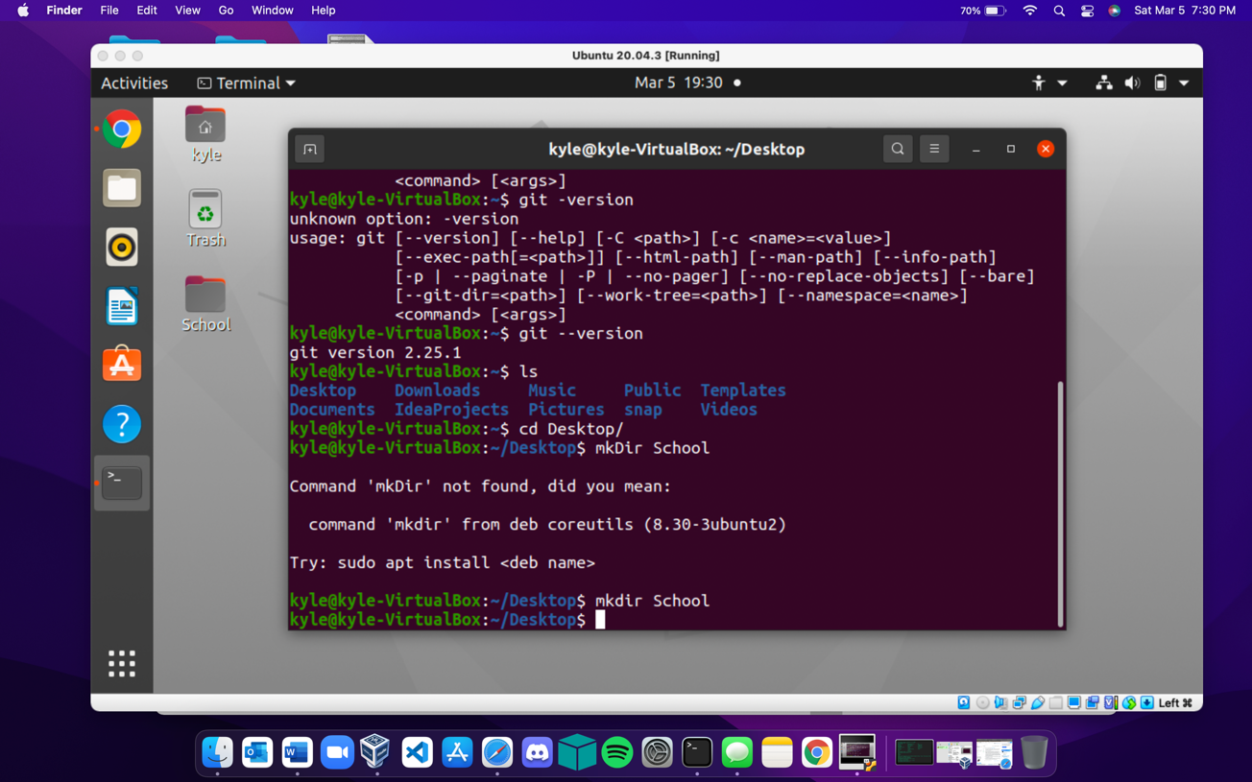

cd

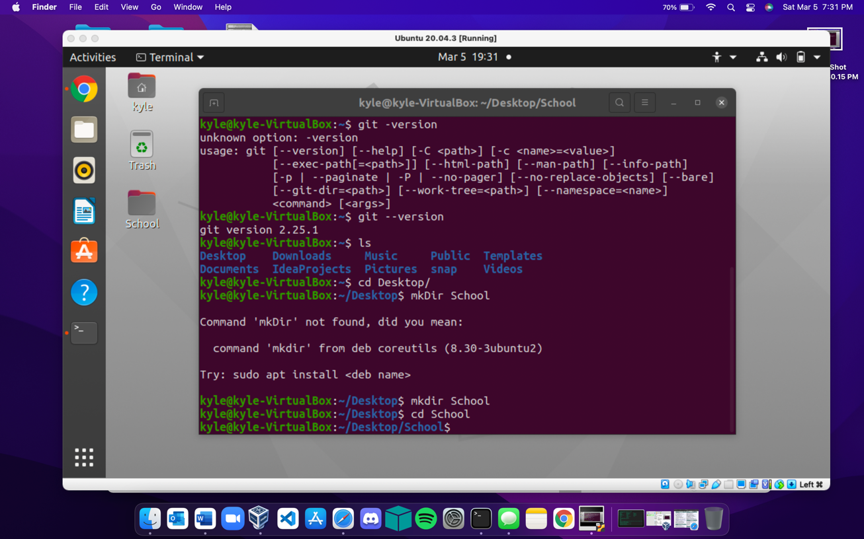

top

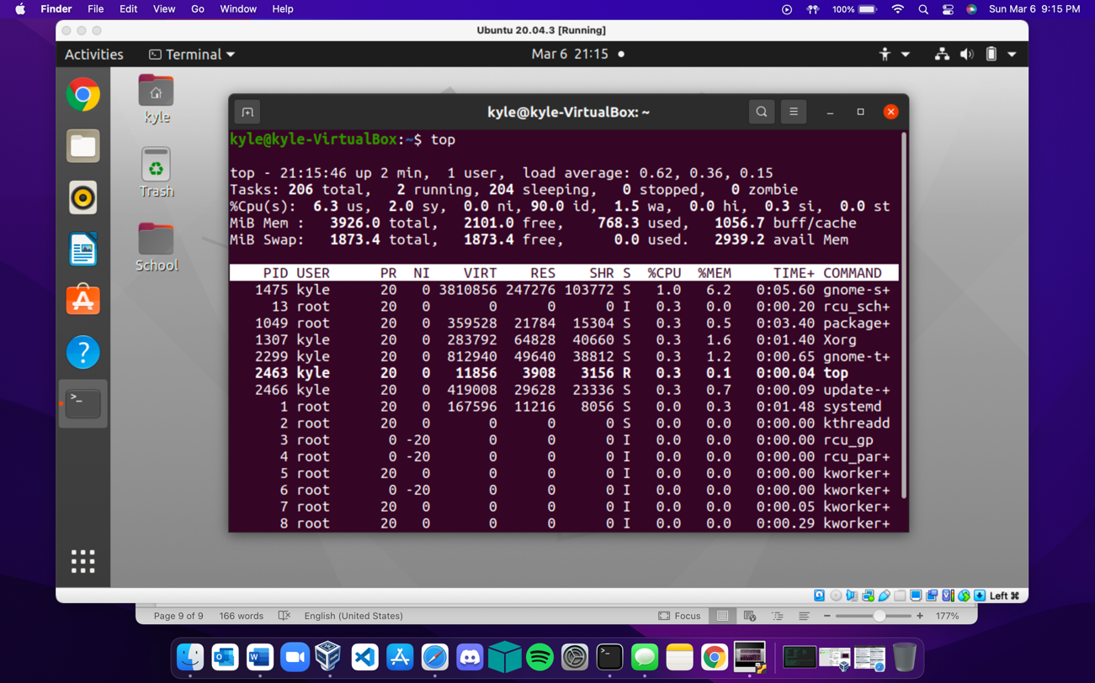

free

